REACT ASSIGNMENTS
Assignment 11:
Aim
To create a React application named eventexamplesapp that demonstrates event handling, synthetic events, multiple event handlers, passing arguments to event handlers, and a Currency Converter component using React.
1. Create a new React application named eventexamplesapp.
npx create-react-app eventexamplesapp
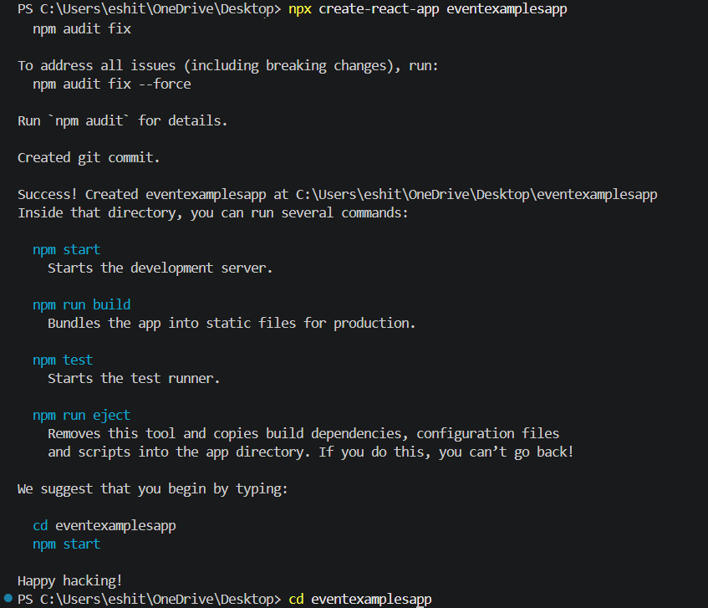
2. Navigate to the project folder.
cd eventexamplesapp
3. App.js
import './App.css';
import { useState } from 'react';
import CurrencyConvertor from './Components/CurrencyConvertor';

function App() {

const [count, setCount] = useState(0);

const increment = () => {
setCount(count + 1);
};

const decrement = () => {
setCount(count - 1);
};

const sayHello = () => {
alert("Hello! Have a nice day.");
};

const handleIncrement = () => {
increment();
sayHello();
};

const sayWelcome = (message) => {
alert(message);
};

const onPress = () => {
alert("I was clicked");
};

return (
<div className="App">

<h1>React Event Examples</h1>

<h2>Counter : {count}</h2>

<button onClick={handleIncrement}>
Increment
</button>

<button onClick={decrement}>
Decrement
</button>

<br /><br />

<button onClick={() => sayWelcome("Welcome")}>
Say Welcome
</button>

<br /><br />

<button onClick={onPress}>
OnPress
</button>

<hr />

<CurrencyConvertor />

</div>
);
}

export default App;

4. Components/CurrencyConvertor.js
import React, { useState } from "react";

function CurrencyConvertor() {

const [rupees, setRupees] = useState("");
const [euro, setEuro] = useState("");

const handleSubmit = () => {

const result = (rupees / 90).toFixed(2);

setEuro(result);
};

return (

<div>

<h2>Currency Convertor</h2>

<input
type="number"
placeholder="Enter Rupees"
value={rupees}
onChange={(e) => setRupees(e.target.value)}
/>

<br /><br />

<button onClick={handleSubmit}>
Convert
</button>

<br /><br />

<h3>Euro : €{euro}</h3>

</div>

);
}

export default CurrencyConvertor;
5. Result
The React application was developed successfully. Different types of event handling were implemented, including multiple function calls, passing arguments to event handlers, synthetic events, and a Currency Converter component that converts Indian Rupees into Euros when the Convert button is clicked.
6. Output
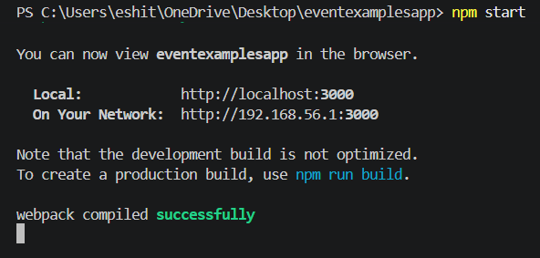
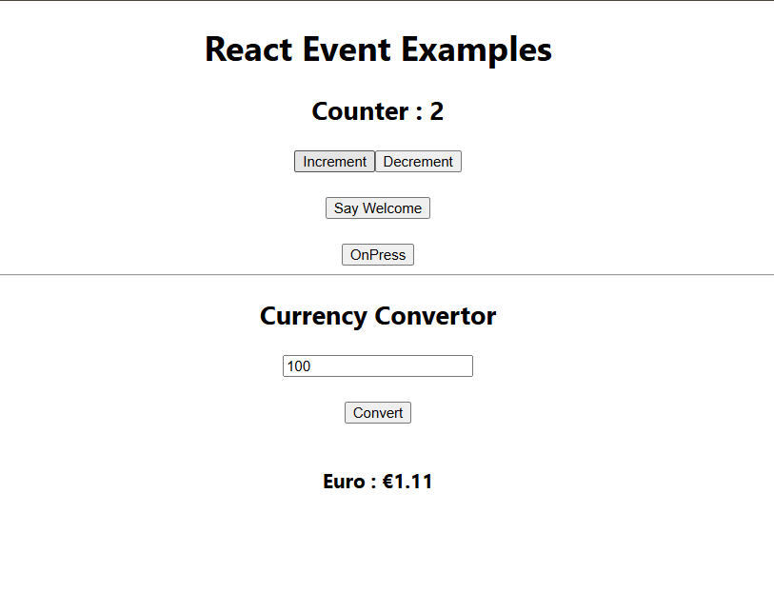
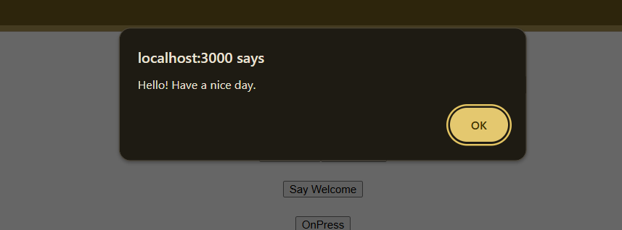
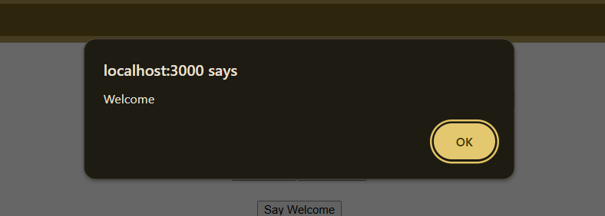
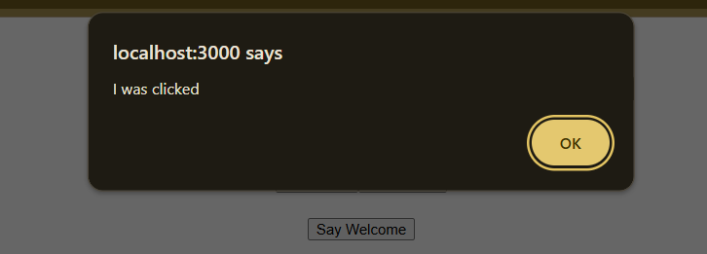

7. Conclusion
The experiment was completed successfully. A React application named eventexamplesapp was created to demonstrate various event handling techniques, including invoking multiple methods, passing arguments to event handlers, handling synthetic events, and implementing a Currency Converter using React state and event handling. This experiment helped in understanding how user interactions are handled efficiently in React applications.

